Species Module
Horses and other equidae

Introduction
These notes will cover information relating to the use of horses in research procedures under the headings;
- Basic biology, anatomy, physiology and reproduction of horses
- Husbandry and care of horses
- Diseases of horses and recognition of pain, suffering, distress and lasting harm
- Minor procedures on horses
Basic biology, anatomy, physiology and reproduction of horses
Equidae are placental mammals from the Order Perissodactyla , which includes other odd-toed ungulates including tapirs and rhinoceri.

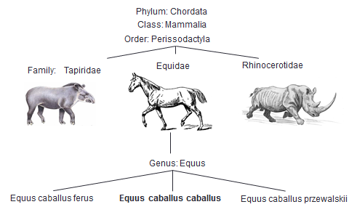

Horses use the tips of their single toe (the third phalanx) to sustain their whole body weight while moving and are athletic flight animals with the ability to jump. Przewalski’s horse is the only remaining wild horse, now reintroduced to its natural habitat on the steppes of the Mongolian-China border. The horse is a herbivore which naturally spends most of the day grazing pastureland although has been domesticated (Equus caballus caballus) to spend considerable amount of time in stables.
The head of the horse is large, with laterally positioned eyes, enabling a wide field of vision to detect predators. The skull contains several large air-filled sinuses and a guttural pouch, a dilation of the Eustachian tube which reduces weight. Horses breathe only through their noses and dilate their nares (nostrils) when active.
The dental formula of horses can be summarised;
 | Incisors (upper/lower) | Canine  (upper/lower) | Premolar  (upper/lower) | Molar  (upper/lower)
Temporary (deciduous) | 3/3 | 0/0 | 3/3 | 0/0
Adult (permanent) | 3/3 | 1/1 | 3/3 or 4/3 | 3/3

The canine teeth are more commonly found in male animals and occupy the interdental space, the large gap between the incisors and the first premolar. Most of the permanent teeth will have erupted by 5 years old and sometimes the deciduous teeth from caps on top of the emerging permanent tooth from below. The incisor teeth can be used to age horses although this is more accurate in young animals (considering time of appearance, angle between upper and lower incisors, cross sectional shape of the grinding surface and appearance of the dental star (pulp) and the infundibulum). Wolf teeth (small vestigial teeth often found immediately in front of the premolars) are commonly extracted as they interfere with the action of the bit in riding animals.
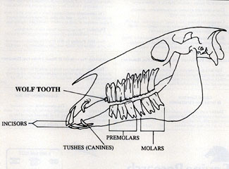
The horse is a monogastric herbivore (unlike the ruminant species) and fermentation of ingesta takes place in the hindgut- in a large caecum which occupies most of the right caudal abdomen. The horse’s stomach is small in relation to overall body size (a consequence of trickle feeding) and the well-developed cardiac sphincter muscle at the oesophageal/ stomach junction prevents vomiting under normal circumstances.
The classification of an equine animal as a horse or pony is generally based on height at the withers, the highest point of the shoulders. Horses are measured in hands, where one hand is four inches and animals over 14.2 hands high or HH (1.47m) are considered to be horses.
There are several pony breeds native to the United Kingdom and Ireland, most of mountain and moorland origins. The most well known breeds of horse are the Arab and the Thoroughbred (descended from Arabian stock). Lighter built horses and ponies are used for riding and heavier “cold-blooded” draught or dray horses for pulling carts. Crossing “hot-blooded” horses like the Arab and TB with draught type horses produces “warmbloods”, a popular middleweight horse type throughout Europe suitable for many equestrian sports.
The donkey, Equus asinus, used as a load carrying animal in developing countries is most commonly kept as a pet or companion in the U.K. Donkeys will mate with horses and the resulting offspring is either a mule or a hinny (mules from a male (jack) donkey and a female (mare) horse, hinnies from a male (stallion) horse and a female (jenny) donkey. Mules and hinnies are often sterile.
Horses are seasonal breeders with mares coming into oestrus in response to increasing daylength in the Northern hemisphere. Mares cycle (“come in season”) approximately every three weeks during the spring and summer months and are only receptive to the stallion at this time and ovulation occurs 24-48 hours before the end of the heat period. It is common stud farm practice to “tease” mares with another lower value or pony stallion first before introducing the valuable stud horse, to reduce the risk of injury if the mare is not in season. Gestation length is 340 days (11 months) and most matings result in one offspring. Twin pregnancies do occur, most often as a result of multiple ovulations (non-identical twins) and as these are associated with an increased risk of abortion, still birth or poor growth and development one foetus of a twin pregnancy is generally aborted by manually crushing the embryonic vesicle under ultrasound guidance, prior to fixation around day 16.
Parturition is rapid, mares deliver foals within 30 minutes, generally at night. Mares are sensitive to disturbance and observations should be carefully managed. A male foal is termed a “colt” and a female a “filly”. Foals are reasonably well developed at birth and after an initial few hours of being wobbly on their legs are able to keep up with the dam. It is important to check that the whole placenta has been delivered after birth as retention of the foetal membranes can make the mare toxaemic.
Artificial insemination techniques are commonly used and stallions are trained to mount “dummy” mares while the ejaculate is collected in an artificial vagina, a double-layered thermal flask which can be filled with iced water to keep the sample cool prior to shipping or freezing.
Care and management of horses
Routine maintenance of horses may involve;
Regular attention from a farrier is advised, even if the horse does not need to be shod as regular trimming will balance the feet and prevent splitting or cracks appearing in the horn of the hoof capsule.
Horses in the U.K. are commonly vaccinated against equine influenza virus and tetanus, an anaerobic bacteria which is found in soil and can cause death following severe muscle spasms leading to respiratory failure. Vaccinations should be recorded in the horse’s passport.
Equine dentistry has been recently developed as a professional discipline, separate to veterinary care and both power and hand tools can be used to reduce sharp enamel points on horses’ teeth (floating) which prevent efficient mastication, in addition to other procedures. Horses may require sedation to permit a full oral exam, a Hausmann gag is used to open the mouth enabling the hand, or a long dental mirror to be inserted to check the teeth.
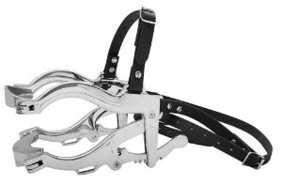
Horses may carry a variety of internal or external parasites. External parasites are most often seen in animals in poor body condition housed in high densities in cold weather conditions; pediculosis (lice infestation with either Haemtopinus asini (sucking lice) and Damalinia equi (biting lice) can be seen with the naked eye whereas mange (an intensely itchy infestation with Chorioptes mites, commonly on the lower limbs of horses with feathered legs) requires skin scrapes to diagnose. Harvest mites (Trombicula autumnalis), an orange coloured insect may also affect the lower limbs and muzzle of grazing animals in the autumn. Intestinal parasites can be broadly divided into small strongyles/redworms (cyathostomes) whose larvae can encyst or overwinter in the intestinal walls, large strongyles and tapeworms which live in the large intestine and are shed in the horses’ droppings and pinworms which lay eggs around the anus leading to irritation and rubbing. Worm infestations are propagated by faeco-oral transmission so one of the most effective control measures is “poo-picking” the pasture regularly and harrowing fields to expose the worm eggs and larvae to sunlight which results in dessication. If the worm burden of a horse is known (by conducting worm egg counts on faecal samples) then deworming can be targeted to the worm species found which reduces the development of resistance to anthelminitic drugs, which is a significant problem. Professional advice should be sought when designing worming programmes.
Flies can significantly bother horses at pasture. “Sweet itch” is a hypersensitivity to the saliva of the Culicoides midge and affected horses develop areas of hair loss and raw, broken skin mostly along the mane, dorsum and tail head as a result. Management is by stabling horses at dawn and dusk when midges are most active, avoiding pastures near standing water and using barriers such as rugs and hoods and fly fringes in addition to topical insect repellents.
Most horse owners groom their animals regularly which propagates a bond of trust and enables easy health inspections. Riding horses are often clipped in the winter when their heavy coats prevent sweat drying and limit their use. Rugs should be used after clipping (or in thinner skinned horses all year round) to prevent cold. Rugs left on horses at pasture should be checked daily for rubs or sores, or displacement of straps which could trap limbs or trip the animal.
Handling horses requires caution as they are large, flight animals which panic easily although this is often breed dependant. Handlers should wear sturdy footwear in case the get stamped on and possibly a helmet, depending on circumstances. Horses can be led using a headcollar or rope halter and conventionally most people lead a horse from its left side. If horses are tied up (to a ring in a wall or the bar or a gate) a loop of breakable twine and a quick release knot should be used as if the horse panics and pulls back it will be able to get free without injury (or breaking the ring off the wall or the gate). Horses should be accustomed to having all their feet picked up at an early age to make routine farriery and foot maintenance easy. Handlers should crouch or bend over when working around horses’ feet and legs, never sitting on the floor. If a second person is inspecting/ shoeing/injecting or even just grooming a horse then the handler should stand on the same side as the horse will naturally move away from the intervention if it is suddenly painful or irritant. Horses kick backwards with their hind limbs so take great care to avoid standing behind them where possible. “Twitching” a horse, where a fold of skin on the neck is held or the upper lip is firmly pinched can permit quick interventions like injections. Intractable or very anxious horses can be sedated or placed in stocks for examinations or procedures.

Horses are commonly kept in groups at pasture, with at least one acre per head recommended. If horses are stable kept then they should be provided long fibre (hay/ haylage) at frequent intervals throughout the day. Horses used for riding are given additional energy-dense cereal based feeds; oats, maize and barley which may have added molasses to increase palatability. There are many proprietary ready mixed diets on the market for various breeds, ages and intended use of horse. Horses should still consume 1-2% of their bodyweight as long fibre, even if cereals are fed. Fresh fruit and vegetables can be fed to increase variety, carrots and apples are typical but horses will also eat pears, parsnips, turnips and squashes which are of a reasonable size and relatively inexpensive. Onions, potatoes, tomatoes, broccoli and cauliflower may cause gastrointestinal upset and should not be fed. Straw or woodshavings are commonly used as bedding materials in stables, peat and shredded paper are also used. Horses with respiratory allergies should be fed haylage and stabled on paper to reduce dust levels. The horse’s natural feeding posture is to eat off the floor although raised water drinkers, feed troughs and automatic water dispensers are often seen, these should not be too high so that natural head carriage is exceeded when eating or drinking.
The Code of Practice for the Housing and Care of Animals Bred, Supplied and Used for Scientific Purposes currently advises that horses should have a minimum area of floor space when stabled singly or kept in groups based on their height;
Height in  HH/m | Minimum floor area (m²) as singles or in groups <3 | Minimum floor area (m²) as singles or in groups <4 | Mare with foal (m²) | Minimum enclosure height (m)
<14.2/1.47 | 12 | 6 | 16 | 3
14.2- 15.3  (1.47-1.60) | 17 | 9 | 20 | 3
>15.3 (1.60) | 20 | (2xWH)² | 20 | 3

and that management systems should take into consideration horse’s natural behaviour, in particular the need to graze, exercise and socialise, with access to pasture for at least 6 hours per day. Environmental enrichment prevents boredom and the development of stereotypic behaviours such as weaving, box walking and crib biting. Sight of other horses is beneficial when stabled but if this is not possible, fixing a large, shatterproof mirror to the stable wall seems to calm some horses (it is thought that they perceive it to be another horse). Feeding little and often and providing enrichment toys which may incorporate food rewards can also be used.
Horses can be easily identified by their colour and any white markings such as star, snip, blaze or stripe on the face and fetlock, sock or stocking on the limbs. Changes in the direction of the coat, called whorls may also be noted according to their location on the body.
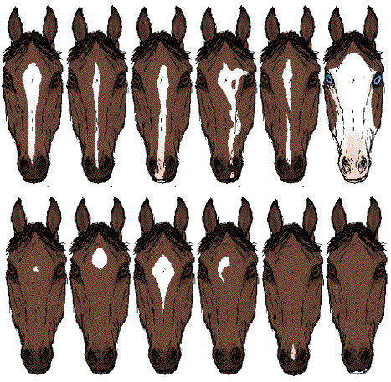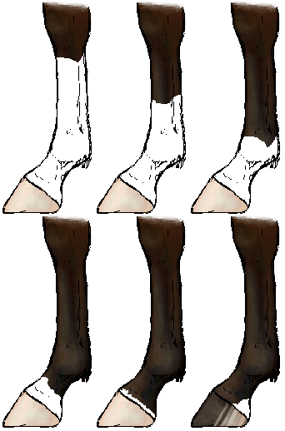
Recently, it has become law to identify horses using an equine passport (to document the use of any medicines in animals which may enter the human food chain) and it has been compulsory to microchip horses for this purpose since 2009. The microchip is injected directly into the nuchal ligament along the top of the neck (not subcutaneously as in dogs and cats) and the passport should be produced at the time of selling the horse or when it is treated by a veterinary surgeon.
Diseases of horses and recognition of pain, suffering, distress and lasting harm
Common equine diseases
Lameness
Lameness workups engage a significant part of an equine vet’s time and horses may go lame following traumatic injury (from kicks or barbed wire fences), due to joint disease (osteochondritis dissecans, osteoarthritis), tendonitis and primary foot conditions such as subsolar abscesses or “pus-in-the-foot”, corns and nail bind following shoeing. Horses with foot pain will usually present with a non-weightbearing lameness and an increased digital pulse, palpable along the medial side of the cannon bone or just above the bulbs of the heels. Laminitis is a condition where the ischaemia of the laminae between the hoof capsule and the third phalanx or pedal bone break down and pedal bone rotation occurs. Carbohydrate overload and obesity precipitates laminitis but it can also be associated with Cushings disease, most often in elderly horses. Laminitis is extremely painful and the affected horse will be reluctant to move and may adopt a rocked back posture to relieve pressure on the front of the hoof capsule. Treatment is analgesics and application of pedal bone support to prevent further rotation, which may not be successful.
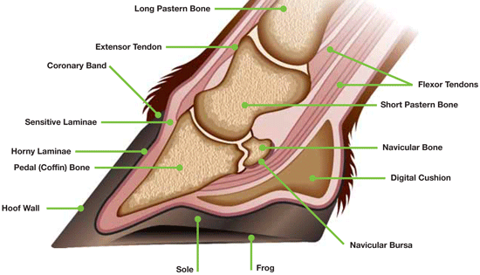
www.equinepainmatters.com
Colic is a general term for abdominal pain and can be benign or life-threatening. Changes in gut motility and blood flow are painful and horses will become restless, sweat, paw at the ground, roll and even remain on the ground in an unnatural posture (i.e. on their backs) when colicking. Colic may be due to a heavy worm burden, gut spasms, a build up of gas, an obstruction or a twist or torsion of the intestine amongst other causes. Rectal examination will help to diagnose the cause but it is not possible to palpate all of the abdomen, especially in larger horses. Obstructions which cannot be relieved or torsions represent surgical emergencies and the horse should be transported to an equine hospital if it continues to show signs of pain despite analgesia, spasmolytics or fluid administration or toxaemia (elevated heart rates, poor pulse quality, increasing purple coloration of the mucous membranes) Contrary to popular belief, letting a horse roll does not increase the risk of the gut twisting and there is no need to walk colicking horses incessantly. Colicking horses should be given adequate space and soft bedding and allowed to select their most comfortable position. Food should be removed until the horse has recovered and/or passed droppings.
Choke occurs when a food item gets lodged in the oesophagus. It can appear distressing as the horse often has a copious nasal discharge (saliva mixed with food material) and may make frequent swallowing attempts. Treatment is muscle relaxants and analgesia plus (depending on position of obstruction) passage of a stomach tube and lavage with warm water to break up the obstruction. Most cases of choke resolve spontaneously and it is acceptable to observe the horse over a few hours, a few prolonged cases may need intravenous fluid therapy (all food and water should be removed to prevent aspiration pneumonia, some horses will still try to eat) and possibly further investigation under general anaesthesia if they do not clear.
Respiratory disease can take many forms. Small airway diseases such as chronic obstructive pulmonary disease/ recurrent airway obstruction occur as result of allergies to dust in the stable environment and can be managed with bronchodilators and anti-inflammatory drugs. There are several viruses (more later) which can infect the respiratory tract, causing symptoms such as nasal discharge, coughing and pneumonia. Strangles or infection with the bacterium Streptococcus equi is a highly contagious disease which causes abscessation of the cranial lymph nodes which may burst , leaving open wounds to heal by secondary intention. Horses have a high fever and reduced appetite when infected and can become carriers once recovered, harbouring the bacteria in their guttural pouch. An outbreak of strangles causes quarantine shut down in an area.
Gastric ulceration has been linked with low forage diets, stress and stereotypic behaviours like windsucking. It is most common in athletic horses. Affected horses show a drop in performance, appetite and possibly body weight. Diagnosis is via gastroendoscopy and treatment by administration of gastroprotectant drugs and changing the horse’s routine to reduce stress.
Ocular injuries are very common. Flies irritate horses’ eyes and rubbing or any other accidental trauma may induce conjunctivitis or even corneal damage. Horses are prone to uveitis, inflammation of the uveal tract (the iris, ciliary body and the choroid) and symptoms include painful, red eyes, photophobia, corneal oedema (grey white colouration of the normally clear surface of the eye) and changes in the margin of the pupil. Uveitis is very painful and should not be left untreated. Injuries to the eyelids may require suturing to preserve the integrity of the blink reflex, which distributes the tear film over the eye’s surface, fortunately the lids have a good blood supply and tend to heal well.
Sarcoids are skin tumours, thought to be caused by a papillomavirus, transmitted by biting flies. There are 6 recognised types of sarcoid and they can occur anywhere on the body and vary between flat, plaque like lesions to verrucose- cauliflower like swellings. Sarcoids are only problematic if they are in a place that the horse’s tack or rug will rub, if they are around areas like the eye, causing irritation or if they are aggressive or fast growing or spread to other areas. Barrier fly control may be necessary in summer. Horses with existing sarcoids may develop them in other areas, particularly when wounds heal. Radiotherapy is the most effective treatment but the costs are prohibitive.
Mudfever and rainscald occur in bad weather, as their names suggest. Mudfever affects the lower limbs and thin skinned horses with white hair (underlying pink skin) seem to be more susceptible. Wet damp conditions predispose to cracks in the skin’s barrier and the bacteria Dermatophilus congolensis can invade, causing dermatitis and scabbing. Treatment is by local cleaning and skin care and antibiotics are usually required. Dermatophilosis also occurs in other areas of the body such as the neck, back and rump of the horse (rainscald) and small bumps and scabs can be felt through the coat which may be itchy. Medicated treatment shampoos are useful but both conditions can be managed by keeping the skin as clean and dry as possible.
Sweet itch has been described previously.
Notifiable diseases
 | Last seen in the U.K.
West Nile Virus | never
Equine Viral Arteritis | 2012
Equine Infectious Anaemia | 2012
African Horse Sickness | never
Dourine | never
Epizootic lymphangitis | 1906
Anthrax | 2006 (in cattle)

If a horse is suspected of being infected by one of these diseases then the local Animal and Plant Health Agency should be notified immediately. EVA results in respiratory and reproductive symptoms (nasal discharge and abortions in pregnant mares) and stallions can carry the virus subclinically after recovery from infection. Other symptoms are conjunctivitis and fever. EIA is transmitted by flies, therefore more likely in the warmer months, affected horses are feverish and depressed and may lose weight.
Vaccination
Horses in the U.K. are routinely vaccinated on a yearly basis, against either or both tetanus and equine influenza. Clostridium tetani is an anaerobic bacteria found in soil and infection usually occurs via cuts and wounds. Any horse which sustains a wound and is not covered by an up-to-date tetanus toxoid vaccine is usually given a tetanus anti-toxin injection to cover the healing period. Equine influenza is a worldwide disease of horses and several strains of virus are recognised. Most equine competitions and events require all participants to prove their horse’s vaccination status. Horses may also be vaccinated against Strangles, equine herpesvirus (EHV) and the viruses causing notifiable disease, equine viral arteritis (EVA) and West Nile virus (WNV). It is also possible to vaccinate pregnant mares against rotavirus, to reduce the risk of viral diarrhoea in young foals.
Clinical examination of horses
Some clinical parameters of horses;
Body temperature | 99.5-101ºF (37.5-38ºC)
Respiratory rate | 8-15 breaths/min
Heart rate | 30-40 beats/min
Mucous membrane colour | pink
Capillary refill time | <2 seconds

In addition the horse should be examined all over, checking the skin, the limbs and feet (may trot the horse up to look for lameness) and its overall body condition assessed. If there is no access to a weighing scale then a weightape can be used to estimate body weight. The horse’s primary carer should be aware of any changes in temperament and any change in the frequency of eating, drinking, urinating and defaecating.
Signs of pain or disease in horses include:
- Increased respiratory and heart rates
- Change in temperature
- “Tucked up” posture
- Loss of appetite/lack of droppings
- Discomfort when urinating, abnormal appearance of urine
- Dull or agitated (change from usual mental state)
- Lame
- Diarrhoea
- Ocular or nasal discharge
- Sweating
- Restless/ pacing/ pawing ground/ rolling
- Teeth grinding
- Recumbent
Fate of horses at the end of scientific procedures
Schedule 1 killing of horses
The Animals (Scientific Procedures) Act 1986 stipulates that all animals not killed at the end of a series of scientific procedures must be examined by a vet to ensure that they are not suffering as a result of the interventions applied, before discharge from the controls of the Act and rehoming. Most animals are killed as research scientists require blood and tissues but horses are sufficiently large that they can be used as blood donors without any detrimental effect upon their health, for example so rehoming may occur.
Animals used under ASPA should be killed by a recognised Schedule 1 method, unless another alternative method has been authorised in the Project Licence (PPL). Animals must first be killed, then death completed or confirmed prior to post-mortem tissue collection or disposal. Schedule 1 methods suitable for ungulates are;
Killing by administration of an overdose of anaesthetic (including embryonic horses)

or

Recognised method of slaughter performed by a vet or a person licensed under the Welfare of Animals (Slaughter or Killing) Regulations 1995; destruction of the brain by free bullet or captive bolt or electrical stunning followed by pithing or exsanguination before return of consciousness

Killing can be completed by one of the following methods (any species)
- confirmation of cessation of the circulation
- destruction of the brain
- dislocation of the neck
- confirmation of onset of rigor mortis
- destruction of the body in a macerator

There are obviously some limitations on the completion/confirmation method used due to horses’ size (it would be difficult to dislocate the neck or macerate the body). Confirming cessation of the circulation by palpating a pulse or using a stethoscope or waiting for the onset of rigor mortis are more likely to be used, although onset of rigor takes longer in larger animals. A firearms licence is necessary to hold and use free bullet guns.
Overdose of anaesthetic usually involves an intravenous injection of pentobarbital sodium (Dolethal, Lethobarb, Euthatal, Pentoject) or quinalbarbitone sodium (Somulose). It is permissible under ASPA to pre-sedate the horse prior to any method of killing, to reduce anxiety and to aid placement of an intravenous catheter in the case of anaesthetic overdose, advisable where large volumes are injected into the vein.
Shooting horses requires training as the bullet trajectory must be accurately aimed at the base (rear) of the brain as shown below;
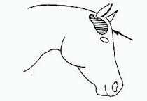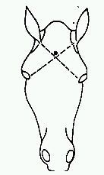
Horses tend to fall suddenly to the ground when shot (also occasionally after anaesthetic overdose) so the area where the killing takes place should have sufficient space for personnel to get out of the way. It should be quiet and away from other animals and allow easy access for a tractor or knackerman’s horsebox. Shooting results in haemorrhage from the nostrils so it may useful to have a large plastic bag to hand to place under the horse’s muzzle once it goes down.
Minor procedures on horses
Administration of substances
For all substances
Dose = dose rate(mg/kg) x horse’s weight(kg)
drug concentration(mg/ml)
Substances may be administered by various routes;
Orally administration - mixed in food/ water
- via an orally dosed paste
- via stomach tube

Stomach tubing horses requires skill and the horse may need to be twitched or sedated first. Two people are required, one to pass the stomach tube via one nostril to the nasopharynx and one to position the horse’s head to prevent passage of the tube into the trachea. The head and neck are flexed;

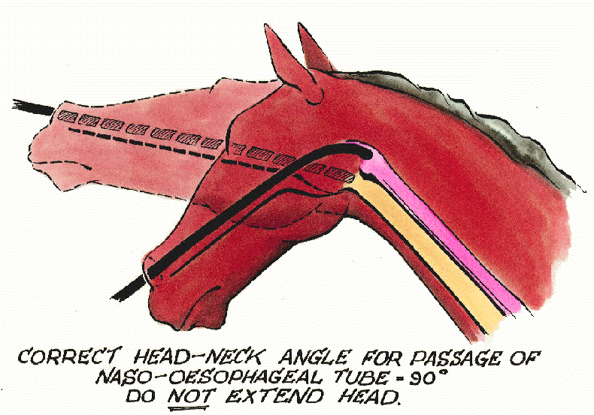

The stomach tube is should be visible as it passes down the oesophagus, just above the jugular furrow on the horse’s left side. Gentle pressure on the larynx will produce a “rattle” of the tube against cartilage if the tube has been misdirected and the horse will likely cough. Stomach tubing may cause nasal haemorrhages if roughly done or horses are allowed to shake their heads as the tube passes through the nasal cavity.

Topical administration to the skin (may require clipping)
to the gingivae (gums)
to the surface of the eye

For all injections the smallest gauge needle possible should be used, whilst still being able to deliver the substance. Needle should always be inserted with the bevel facing away from the skin, so the pointed tip enters the animal first, reducing trauma. Typical needle sizes used for horses are 18, 19, 20 and 21G with a length of 1.5 inches required for intramuscular injections. It is advisable to swab the skin over the injection site using alcohol or surgical spirit to prevent introduction of infection.

Subcutaneous injection under the skin usually over the shoulder or neck. A pinch of skin is grasped and the needle placed underneath.
Intramuscular injection in the neck (most commonly used)
in the pectoral muscles
in the rump (gluteal muscles)

Intramuscular injections are relatively straightforward in the horse with the neck being used in preference to other sites for safety reasons although repeated or large volume injections can make the horse stiff. The needle is inserted perpendicular to the skin’s surface within a triangular area bordered by the front of the shoulder, the nuchal ligament and the vertebral processes of the spine.
Intravenous injection into the jugular vein on either side of the neck. The vein is visible when raised (or the hair can be clipped if not) and the bevel of the needle is inserted, following the angle of the vessel. Some blood should be visible in the needle hub and if the syringe is already attached at this point the plunger can be pulled back slightly to check that blood is drawn into the syringe. The carotid artery runs adjacent to the jugular vein lower in the neck so the top third of the vein is usually used to minimise the risk of intra-arterial injection. Allowing the horse to twist its neck will expose the carotid and if hit, a rapid, higher pressure flash or jet of blood will be seen in the needle hub or syringe and the needle should be redirected.
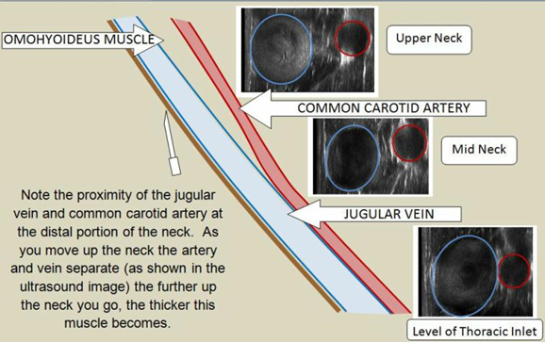

Taking samples
Blood is usually collected from the jugular vein via a syringe or vacutainer. Collecting large quantities requires a large bore needle and local anaesthesia can be used to reduce pain on needle insertion. The total blood volume of a horse is approximately 65ml/kg body weight, therefore 10% of TBV of a 500 kg horse can be calculated;
0.1 x (65 x 500) = 3.25 litres
(ASPA limits for mild blood sampling are 10% TBV on one occasion and 15% TBV over 28 days)
Skin samples can be collected as scrapes or biopsies. Sedation and/or local anaesthesia may be required.
Faecal samples can be collected as voided or from the rectum.
Urine samples can be collected as voided or via a urinary catheter (easier in male horses, sedation will be required)
Respiratory tract samples include nasopharyngeal swabs where a swab is passed up into the nasal cavity towards the back of the throat and tracheal washes and bronchoalveolar lavages; both obtained using an endoscope passed down the trachea to instill sterile saline and recover cellular samples from the lining of the lower airways (sedation required).

Sedation and anaesthesia of horses
Horses have a stay reflex, a series of ligaments within their lower limbs that enable them to sleep standing up and giving low doses of anaesthetic agents results in standing sedation which is useful in the field. Drugs are usually given by intravenous injection although there is an oral paste containing an α2 agonist currently available. Standing sedation avoids some of the issues associated with general anaesthesia in the horse but great care should be taken as the horse may stumble (usually shortly after induction of sedation) and will still kick. Depending on dose and combination of agents, most standing sedations will last 30- 45 minutes (top-ups can be given as required) and maintaining a quiet environment will enhance this. Local anaesthetic injections can be used around the site of the procedure (i.e. infraorbital nerve blocks during dentistry) to block pain signals and this allows a reduction the doses of anaesthetic drugs required.
The most commonly used agents for standing sedation are the α2 adrenoreceptor agonists detomidine, romifidine or xylazine and they are often combined with butorphanol (an opioid drugs with better sedative than painkilling properties) given together in one syringe.
Some dose rates for α 2 agonists;
Romifidine (Sedivet 10mg/ml) : 40-120mcg/kg body weight
Detomidine (Domosedan 10mg/ml) : 20mcg/kg (light)
40mcg/kg (medium)
80 mcg/kg (deep sedation)
Xylazine (Rompun 2% 20mg/ml): 0.6-1.0mg/kg
Remember that the degree of sedation is dose dependent so it is better to underdose and top-up.
Dose rate for butorphanol;
Butorphanol (Torbugesic 10mg/ml): 1mg/lkg
The α2 agonist drugs may be antagonised or “reversed” by the administration of atipamezole, this is commonly done in small animal practice but only used in equines to alleviate a poor recovery. Atipamezole does not have a veterinary licence for use in horses (probably because it is rarely necessary to use it, not because of any side effects of the drug). Seek veterinary advice from you NVS should you have any horses suffering poor recovery from α2 agonist sedation.
General anaesthesia of horses is a massive undertaking as their size, temperament and physiology necessitates more specialised equipment than smaller animal species. A pre-med usually given; sedative doses of anaesthetic drugs (α 2 agonists or ACP or both) to reduce anxiety and allow intravenous catheter placement in the jugular vein and analgesics for pre-emptive pain relief. General anaesthesia is then induced intravenously usually with ketamine, although thiopentone (a barbiturate) is sometimes used. Following induction, horses can be maintained under anaesthesia using volatile agents such as halothane or isoflurane delivered via an endotracheal tube (placed via the nose) or via continuous infusion of injectable agents.
Horses are normally induced in a padded stable to avoid injury when they fall although some facilities have specialised tilting tables where the horse is maintained upright against a “wall” using straps and once under anaesthetic the wall is pulled out to form the operating table. Due to their size and weight, heavy duty winching apparatus is required to move recumbent horses (so they must be deeply anaesthetised) and operating tables should be well padded to reduce compression and lack of blood flow to dependant parts of the body. Horses are recovered in the padded box as their behaviour may be unpredictable (extra sedatives may be used at this stage) and occasionally fractures may occur as they stagger around. Some horses, despite attention to padding and positioning during surgery will show post-anaesthetic myopathy- stiffness or lameness for a few days after the procedure.
Analgesic drugs
Analgesic drugs should be included in every anaesthetic protocol where there is the potential for pain to occur. Analgesia should start before the onset of the painful stimulus- the surgery- and continue for as many days as necessary post-procedure.
There are 3 types of analgesic drugs
Opioids potent centrally acting painkillers which have additional sedative properties.
Morphine
Buprenorphine (Vetergesic 0.3mg/ml); 5mcg/kg
Pethidine (Pethidine 50mg/ml): 2mg/kg
Butorphanol- see above.
Non-steroidal anti-inflammatory drugs (NSAIDs) which act at the site of inflammation with no sedative or anaesthetic properties. Oral and injectable formulations are available and the effect generally lasts about 24 hours. Orally administered NSAIDs should be given with food.
Phenylbutazone (Equipalazone 200mg/ml): 4.4mg/kg
Flunixin (Finadyne 50mg/ml): 1.1mg/kg
Ketoprofen (Ketofen 10% 100mg/ml): 2.2mg/kg
Meloxicam (Metacam 20mg/ml): 0.6mg/kg
Carprofen (Rimadyl 50mg/ml): 0.7mg/kg
Local anaesthetics analgesic drugs which are injected locally to the site of pain and block transmission of pain signals to the brain. There is no effect upon the animal’s level of consciousness or motor function. Local anaesthetics have a limited duration of action (hours) and the injectable forms are used diagnostically in nerve and joint blocks to find the site of lameness in horses. Take care as it is possible to overdose local anaesthetics and they do have some systemic effects at high doses, always calculate doses based on the horse’s weight.
Mepivacaine (Intra-Epicaine 2%)
Lignocaine (Lignol 2%)
Local anaesthetics can also be applied topically, as a splash block where the liquid is dripped onto the area from a small syringe or topical creams can be used which are rubbed into the skin (only used creams on intact unbroken skin), allowing time for absorption before the procedure starts.

